Project Design Phase-I
Solution Architecture

Date | 19 September 2026
Team ID | PNT2022TMIDxxxxxx
Project Name | EV Market Analysis (Tableau)
Maximum Marks | 4 Marks

Solution Architecture:
Solution architecture is a complex process – with many sub-processes – that bridges the gap between business problems and technology solutions. Its goals are to:
- Find the best tech solution to solve existing business problems.
- Describe the structure, characteristics, behavior, and other aspects of the software to project stakeholders.
- Define features, development phases, and solution requirements.
- Provide specifications according to which the solution is defined, managed, and delivered.

Sample Solution Architecture Diagram:
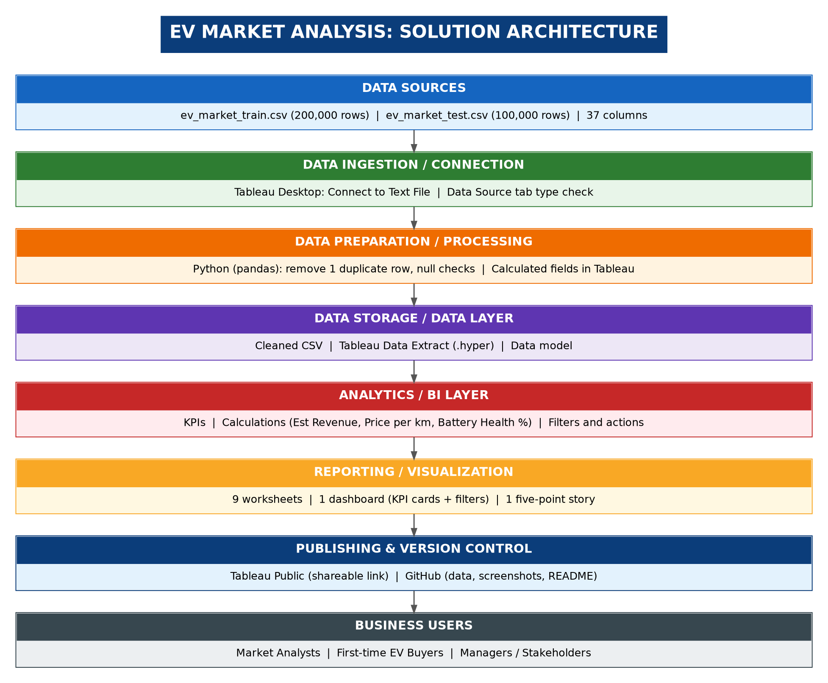

Component Description Table
Component Name | Description / Role in Architecture | Technology Used
Data Sources | Raw EV vehicle data: train file (200,000 rows) and test file (100,000 rows), 37 columns per row | CSV files (ev_market_train.csv, ev_market_test.csv)
Data Ingestion | Loads the CSV files into the analytics tool and checks data types | Tableau Desktop (Connect to Text File)
Data Preparation | Removes 1 duplicate row and checks nulls in key columns before analysis | Python (pandas)
Data Storage | Holds the cleaned data as a Tableau extract for fast dashboard loading | Cleaned CSV, Tableau Data Extract (.hyper)
Analytics / BI Layer | Calculates KPIs and derived fields: Est Revenue, Price per km, Battery Health %, Charging Band, Vehicle Type | Tableau Desktop calculated fields
Reporting / Visualization | 9 worksheets, 1 dashboard with KPI cards and filters, 1 five-point story | Tableau Desktop
Publishing & Version Control | Shares the dashboard link and stores data, screenshots, and README | Tableau Public, GitHub
Business Users | Market analysts, first-time EV buyers, and managers who read insights | Web browser (Tableau Public link)

